# **Install Tomcat Linux**

**Steps To Install Tomcat For Linux:**

1. Download latest Tomcat from <https://tomcat.apache.org/download-90.cgi>

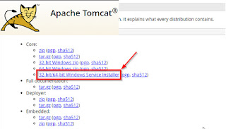

1. Before run the Tomcat installer, make sure you already installed OpenJDK.
2. Copy apache-tomcat-9.0.73.tar.gz to /opt folder.

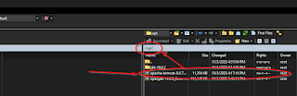

1. Go to /opt and extract tomcat 9 file.

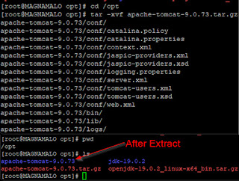

|  |
| --- |
| cd /opt  tar -xvf apache-tomcat-9.0.73.tar.gz |

1. Move tomcat files from the one created to the new one named tomcat9.

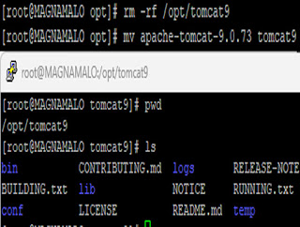

|  |
| --- |
| rm -rf /opt/tomcat9  mv apache-tomcat-9.0.73 tomcat9 |

1. Create a new user named tomcat.

|  |
| --- |
| groupadd --system tomcat  useradd -d /opt/tomcat -r -s /bin/false -g tomcat tomcat |

1. Make tomcat folder owned by tomcat user.

|  |
| --- |
| chown -R tomcat:tomcat /opt/tomcat9 |

1. Create a tomcat.service unit file under /etc/systemd/system/ .

|  |
| --- |
| vi /etc/systemd/system/tomcat.service |

1. Value Inside tomcat.service.

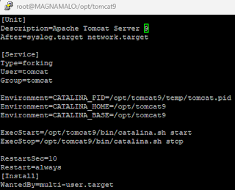

|  |
| --- |
| [Unit]  Description=Apache Tomcat Server 9  After=syslog.target network.target    [Service]  Type=forking  User=tomcat  Group=tomcat    Environment=CATALINA_PID=/opt/tomcat9/temp/tomcat.pid  Environment=CATALINA_HOME=/opt/tomcat9  Environment=CATALINA_BASE=/opt/tomcat9    ExecStart=/opt/tomcat9/bin/catalina.sh start  ExecStop=/opt/tomcat9/bin/catalina.sh stop    RestartSec=10  Restart=always  [Install]  WantedBy=multi-user.target |

1. Reload the systemd configuration.

|  |
| --- |
| systemctl daemon-reload |

1. Start the tomcat service, enable it to auto-start at system boot and check the status.

|  |
| --- |
| systemctl start tomcat.service  systemctl enable tomcat.service  systemctl status tomcat.service |

1. Access tomcat web interface using browser . Use this link to open Tomcat page http://localhost:8080/ .

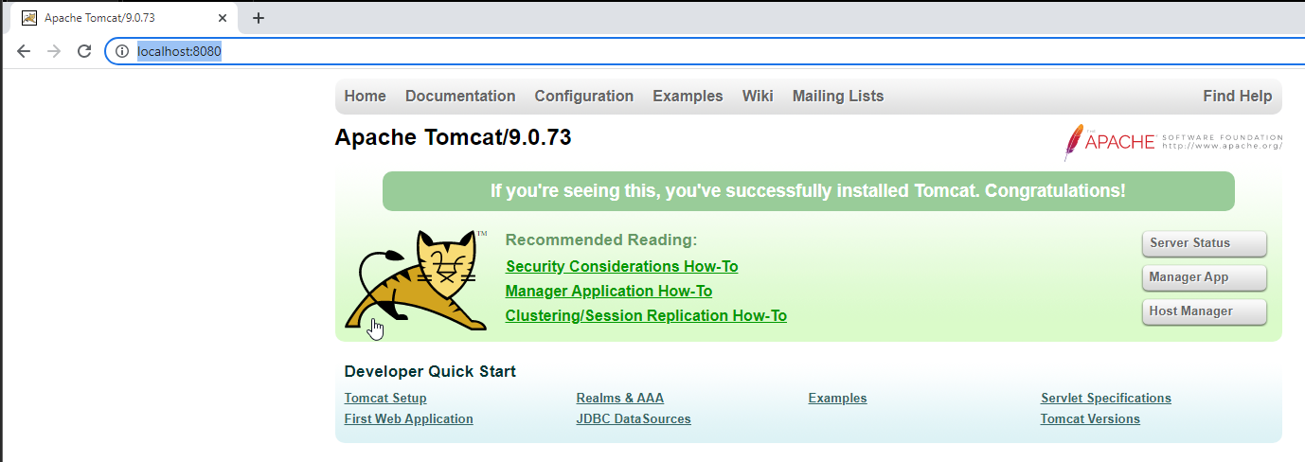

**Steps To Enable HTTPS SSL on Tomcat:**

1. Stop Tomcat service.
2. Go to your OpenJDK or JRE folder. Example like below.

|  |
| --- |
| cd /opt/jdk-19.0.2/bin/ |

1. Generate a self signed certificate.

|  |
| --- |
| /opt/jdk-19.0.2/bin/keytool -genkey -alias tomcat -keyalg RSA -validity 8888 -ext san=ip:127.0.0.1 -keystore "/opt/localhost.jks" |

1. Specify password. Please make sure that you remember your password or maybe you can keep it somewhere safe.

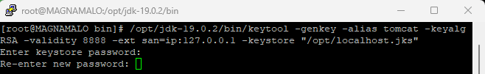

1. Specify First and last Name. Put anything you want.

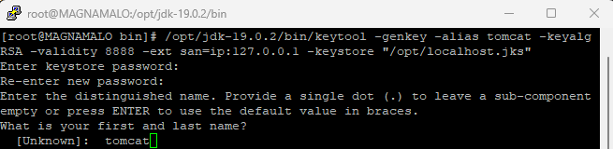

1. Specify organizational unit, organization, City or Locality, State or Province, and country code. If you don't want, just keep it blank.

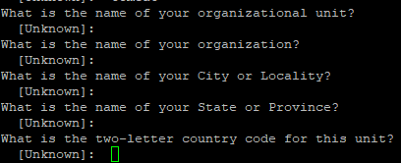

1. Specify “yes” when asked to confirm whether the information is correct.



1. When prompted for key password again, just press enter. If have warning, just ignore it.



1. Go to /opt folder and you will see localhost.jks the keystore you generated previously.

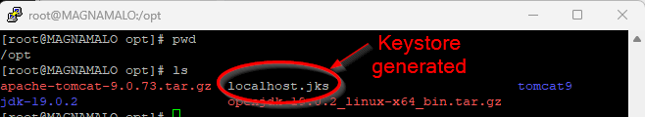

1. Copy the generated file to tomcat's home.

|  |
| --- |
| cp /opt/localhost.jks /opt/tomcat9/ |

1. Make localhost.jks owned by tomcat.

|  |
| --- |
| chown tomcat:tomcat /opt/tomcat9/localhost.jks |

1. Go to /opt/tomcat9/conf, open the tomcat server.xml file, search for :8080 line and add new line to enable HTTPS.

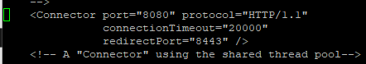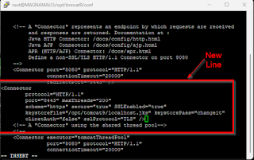

|  |  |
| --- | --- |
| cd /opt/tomcat9/conf/  vi server.xml  Server.xml content   |  | | --- | | <Connector  protocol="HTTP/1.1"  port="8443" maxThreads="200"  scheme="https" secure="true" SSLEnabled="true"  keystoreFile="/opt/tomcat9/localhost.jks" keystorePass="changeit"  clinetAuth="false" sslProtocol="TLS" /> | |

1. Before that, above command need to change the password with what you put previously at number 4.

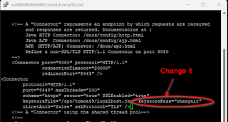

1. Restart tomcat.

|  |
| --- |
| systemctl restart tomcat  systemctl status tomcat |

1. Access tomcat web interface using browser. https://localhost:8443 or https://SERVER_IP:8443 .

